**VISUALIZE DATA USING ANY PLOTTING FRAMEWORK**

1. **SCATTER PLOT CODE:**

# Install ggplot2 (if not already installed) install.packages("ggplot2")

# Load the ggplot2 package library(ggplot2)

# Scatter plot of Sepal.Length vs Sepal.Width, colored by Species ggplot(data = iris, aes(x = Sepal.Length, y = Sepal.Width, color = Species)) + geom_point(size = 3) + # Adds points

labs(title = "Scatter Plot of Sepal Dimensions", x = "Sepal Length (cm)",

y = "Sepal Width (cm)") + # Adds axis labels and title theme_minimal() # Applies a minimal theme

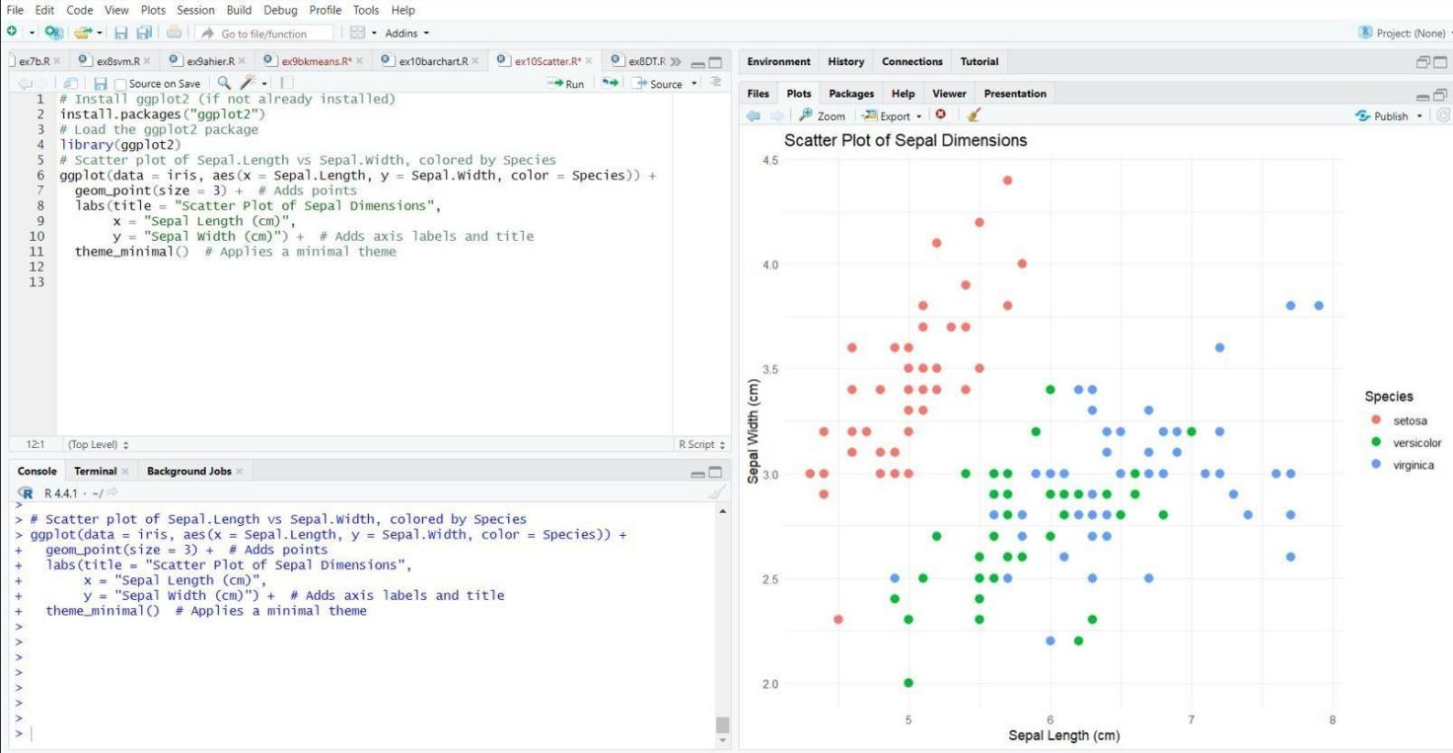**OUTPUT:**

**RESULT:**

Visualizing data using Scatter Plot is executed Successfully.

* 1. **BAR CHART CODE:**

# Load the ggplot2 package library(ggplot2)

# Bar plot of Species counts ggplot(data = iris, aes(x = Species)) +

geom_bar(fill = "steelblue") + # Adds bars filled with steel blue color labs(title = "Count of Different Species in Iris Dataset",

x = "Species", y = "Count") + theme_minimal()

**OUTPUT:**

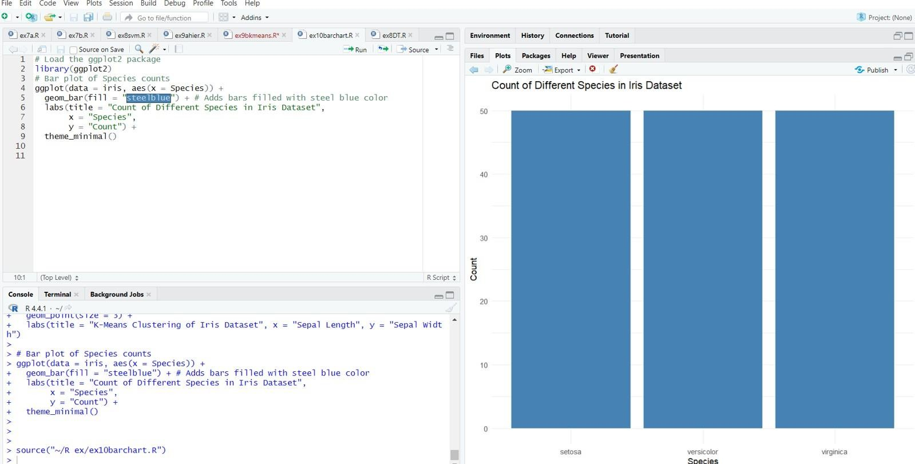

**RESULT:**

Visualizing data using Bar Chart is executed Successfully.

* 1. **HISTOGRAM**

**CODE:**

# Install ggplot2 (if not already installed) install.packages("ggplot2")

# Load the ggplot2 package library(ggplot2)

# Histogram of Sepal Length

ggplot(data = iris, aes(x = Sepal.Length)) +

geom_histogram(binwidth = 0.3, fill = "orange", color = "black") + # Addshistogram bars labs(title = "Histogram of Sepal Length",

x = "Sepal Length (cm)", y = "Frequency") +

theme_minimal()

**OUTPUT:**

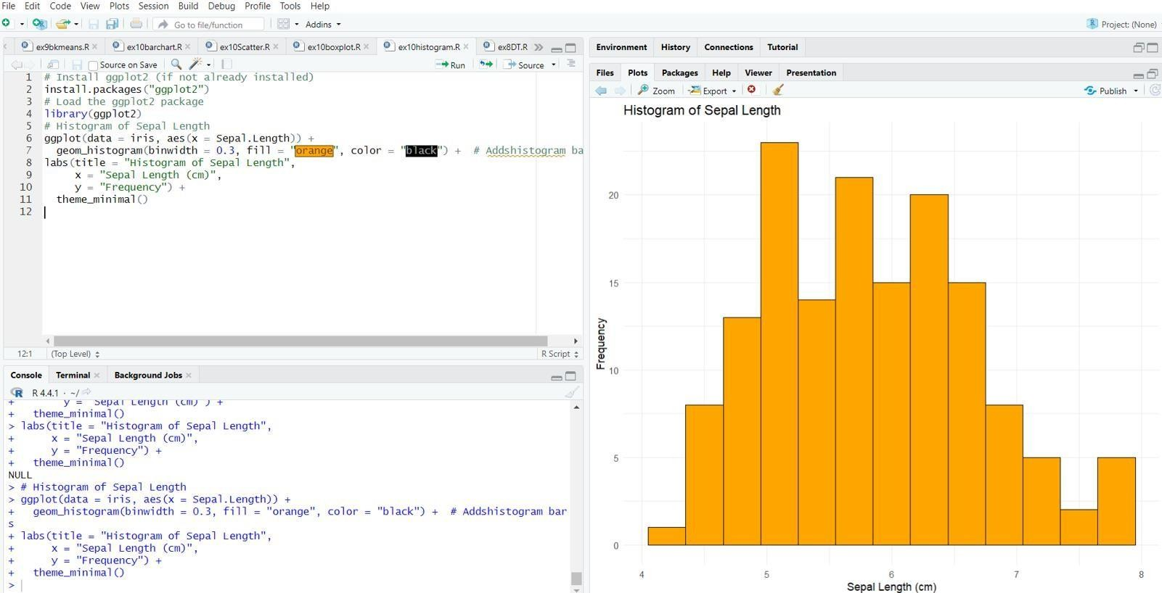

**RESULT:**

Visualizing data using Histogram is executed Successfully.

* 1. **BOX PLOT CODE:**

# Install ggplot2 (if not already installed) install.packages("ggplot2")

# Load the ggplot2 package library(ggplot2)

# Box plot of Sepal Length for each Species

ggplot(data = iris, aes(x = Species, y = Sepal.Length, fill = Species)) + geom_boxplot() + # Adds box plot

labs(title = "Box Plot of Sepal Length by Species", x = "Species",

y = "Sepal Length (cm)") + theme_minimal()

**OUTPUT**:

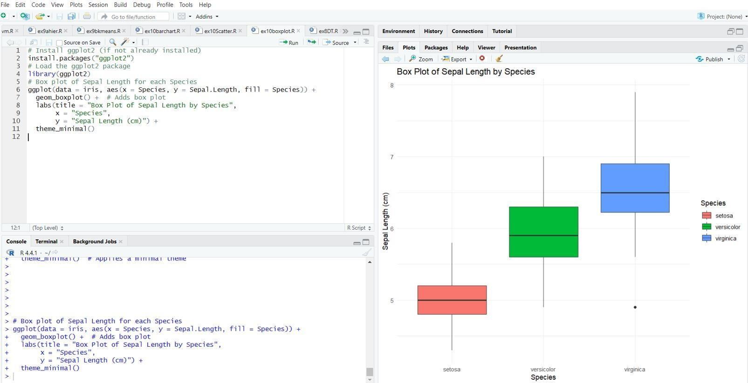

**RESULT:**

Visualizing data using Box Plot is executed Successfully.